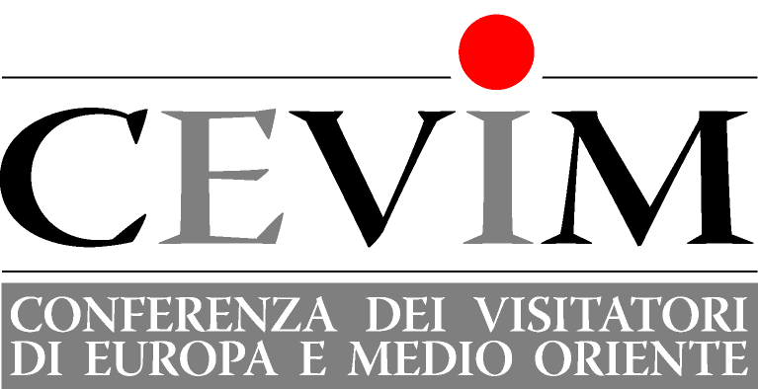 | 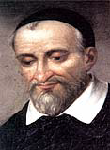 | Segreteria: istabo@virgilio.it  Web site:  www.cm-cevim.org

CEVIM 2012 ASSSEMBLY
Las Palmas, April 16-20

PROGRAMME

Monday April 16:
Evening Welcome and introductions

Tuesday April 17:
8.00 Mass with Lauds included (presided by the Visitor of Germany)
8.45 Breakfast
9.30 Presentation by Jean Landousies on the Lineamenta of the Synod of the Bishops
11.00 Break
  - Presentation by Javier Alvarez Munguía on new evangelisation and St. Vincent
13.00 Break
  - Lunch

16.00 Work in Groups
17.30 Break
18.00 Update on initial and on-going formation in the CEVIM provinces, followed by an exchange guided by Javier Alvarez Munguía
19.30 Vespers
20.00 Dinner

Wednesday April 18:
8.00 Mass with Lauds included (presided by the Visitor of Portugal)
  - Breakfast
9.30 Presentation by Pablo Domínguez Garatachea on new evangelisation and the Vincentian parishes
11.00 Break
  - Response to Superior General’s letter on parishes
13.00 Break
13.15 Lunch

Afternoon Visit to the cathedral of Las Palmas (visit to the Bishop) and to a Vincentian parish.

Thursday April 19:
8.00 Mass with Lauds included (presided by the Visitor of Slovakia)
8.45 Breakfast
9.30 Presentation by Dan Borlik on new evangelisation and the poor
11.00 Break
11.30 Presentation by Stanislav Zontak on new evangelisation and the Vincentian missions in Europe
13.00 Break
13.15 Lunch

16.00 Work in groups
17.30 Break
18.00 Updates on systemic change sessions (Visitors of Italy and Spain), reconfiguration (Visitors of Italy, France and Spain), dialogue with Muslims (Claudio Santangelo).
19.30 Vespers
20.00 Dinner

Friday April 20:
8.30 Lauds.
8.45 Breakfast
9.30 Plenary session: (Vice-Province of St Cyril and Methodius, agreements between provinces on CM foreign students, financial report, website, election of the new CEVIM president, choice of the themes of 2013 CEVIM General Assembly)
12.00 Mass (presided by Javier Alvarez Munguía)
13.15 Lunch

